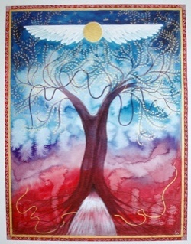
Meditation to Prepare for the Worldwide Womb Blessing

Many women miss out on the simple but beautiful preparation meditation which we can do in advance of receiving the Worldwide Womb Blessing.

This meditation helps us to connect our mind to our womb and its energies. It helps the womb to feel recognised and validated, which prepares it for the beautiful energies in the Blessing. And the meditation helps to balance our womb and cycle energies - whatever our phase.

We can also perform this meditation at any time in our cycles when we feel we need balance and harmony and restoration of our female energy and power.

And if you don’t have a cycle or a womb, you can still take part in the meditation - because you still have a cauldron sitting in your lower belly!

A simple version of the meditation is in the Womb Blessing download document, but here is a longer version.

Enjoy the meditation, and do it whenever you wish - but especially do it in the few days before the Worldwide Womb Blessing.

Bring your awareness to your womb, which lies just below your navel.
Feel, know, or see that a large golden cauldron lined with silver rests in your pelvic girdle. It is filled with beautiful crystal-clear water.

(Pause)

Imagine that you place your hand into the cauldron, and you start to stir the magical waters of this bowl that lies within you.
Make shapes in the water with your hand, and stir up the energies.
As the water swirls it glows with a soft white light.
Relax as you play with the energies of your cauldron.

(Play with the energies for about five minutes.)

Now place your hands over your womb. Feel the bowl lying beneath them glowing with beautiful white energy.

(Pause aware of your lower belly for about five minutes.)
You may experience physical feelings in your womb as it welcomes your attention, or you may feel peace and love and a sense of centredness in your womb, and you may feel old patterns clear.

When you are ready, take a deep breath.
Smile at your womb. And open your eyes.

Drink a glass of water after this meditation to help support any detox.

Remember your womb during the day - and smile at it!

www.wombblessing.com
www.mirandagray.co.uk
https://www.facebook.com/worldwidewombblessing/
https://www.facebook.com/mirandagrayhome/
@wombblessing.mirandagray
@mirandagray.author
@wombblessing
https://www.youtube.com/user/menstrualwisdom

